Minutes of Local Community Development Committee (LCDC) Meeting held 10th July, 2015

Present: Cllr David Fitzgerald, Elected Representative
Declan Rice, County Kilkenny Leader Partnership
Elizabeth Dermody, Social Inclusion Pillar
Fergus Keane, Social Inclusion Pillar
John Bambrick, Irish Farmers Association
John Mulholland, A/CEO Kilkenny County Council
Loretto O’Driscoll, Teagasc
Martin Carroll, Community Pillar
Cllr. Mary Hilda Cavanagh, Elected Representative
Sean McKeown, Local Enterprise Office
Sheila Donnelly, Community Pillar
Sadhbh O’Neill, Substitute for Environmental Pillar
John Hurley, Substitute for Chamber of Commerce
In Attendance: Nickey Brennan, Interim Independent Chairman, Kevin Hanley, A/Chief Officer, Lindsey Butler, Brid Hynes, Lisa Bourke, Aisling Hayes, Stephen O’Connor
Apologies: Eileen Curtis, Carlow Kilkenny Education Training Board
Martin Costello, Kilkenny Chamber of Commerce
Mary Barron, Department of Social Protection
Niall McManus, Environmental Pillar
PJ Cleere, Social Inclusion Pillar
Absent: Cllr. Andrew McGuinness, Elected Representative
Eamon Aylward, Elected Representative
Nickey Brennan commenced the meeting by welcoming the new members to the committee
nominated via the Public Participation Network.
Item 1 – Minutes
The minutes of the previous meeting held on 24th April, 2015 were adopted on the proposal of Sheila Donnelly and seconded by Loreto O’Driscoll.
Item 2 – Correspondence
Kevin Hanley, Chief Officer gave details of all correspondence received, a listing of same was included in the meeting pack, copies of all correspondence were available at the meeting for inspection.
Item 3 – Local Economic and Community Plan (LECP) Update
Sean McKeown presented on the LECP, the purpose of which was to provide an update on submissions received and feedback from the public consultation phase, to note the validity of the draft socio-economic statements and high level goals and to secure approval of the LCDC to progress to the next steps in preparation of the LECP.
Lindsey Butler, Senior Community Development Officer outlined submissions relating to the Community high level goals with Stephen O’Connor detailing submissions received relating to the Economic high level goals (full report included in meeting pack). It was proposed by Sheila Donnelly and seconded by Martin Carroll that:
“The draft socio economic statements and high level Economic and Community goals outlined in the LECP be adopted by the LCDC”
It was agreed that a copy of the report be circulated to those who made submissions.
Item 4 – Social Inclusion and Community Activation Programme (SICAP)
Martin Rafter, County Kilkenny LEADER Partnership (CKLP) presented on the SICAP programme giving details of the background to the programme, goals , the team members and the budget. Alison Allan gave details of targets (copy of presentations and Annual Plan Report included in the meeting pack). Some discussion followed with Nickey Brennan complimenting CKLP on the work to date.
Item 5 – Rural Development Programme Update
It was agreed to deal with this issue last on the agenda.
Declan Rice left the room for the duration of this discussion.
Nickey Brennan outlined the background to the issues in Kilkenny in relation to the delivery of the RDP LEADER programme; members were given a proposal document on the agreement of a joint LAG from County Kilkenny Leader Partnership at the meeting. Sean McKeown outlined the summary of the proposed delivery of the LEADER Programme (document circulated at meeting) as outlined in Government Policy. Nickey Brennan outlined the possible effects of a dual LAG on funding for Kilkenny. He also stressed the importance of full attendance at LCDC meetings given the nature of what the committee were being presented with. Some discussion followed with contributions from David Fitzgerald John Mulholland, Sadhbh O’Neill, Martin Carroll and Mary O’Hanlon.
To enable members time review the CKLP proposal it was agreed to hold a special meeting to discuss it in detail and make a decision on same at 9am on Friday 7th August, 2015. Any member who is not in a position to attend on this date may give their decision to the Chief Officer in advance of the meeting.
Item 6 – Regional LCDC meeting feedback
Kevin Hanley reported on a recent regional LCDC attended by Chief Officers, the purpose of which is for Chief Officers to share information, support staff and give feedback to the Department. It was confirmed at this meeting that updated LCDC guidelines would issue shortly, the next meeting of the group will take place in September, 2015.
Item 7 – Public Participation Network (PPN) Update
Brid Hynes gave an update on the PPN detailing the background, progress to date utilising a four phased approach including details of the PPN election process the results of which were ratified at a plenary session of the PPN held on 16th June, 2015. She also outlined details of work to be completed from July to December, 2015.
Item 8 – LCDC – Identity
Kevin Hanley spoke about the importance of an identity for the LCDC, he presented two options for a LCDC logo, it was unanimously decided to go with the following logo:
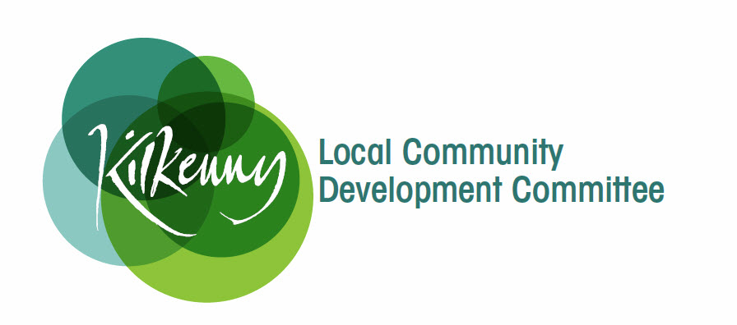
He also confirmed that the domain name www.kilkennylcdc.ie had been registered and will be updated with information shortly.
Item 9 – Standing Orders
It was agreed to defer this item for discussion at the September, 2015 meeting.

This concluded the business of the meeting. It was agreed that the next meeting would be held on Friday 7th August, 2015 at 9am the focus of this meeting will be to discuss the KLP proposal on the agreement of a joint LAG.
The meeting dates for the remainder of 2015 were set as follows, all with a 10.30am start
- 11th September, 2015
- 11th December, 2015

